**Warehouse Table:**

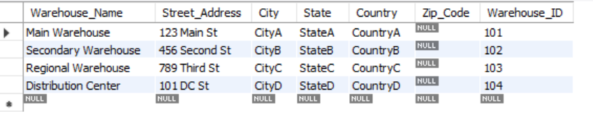

**Store Table:**

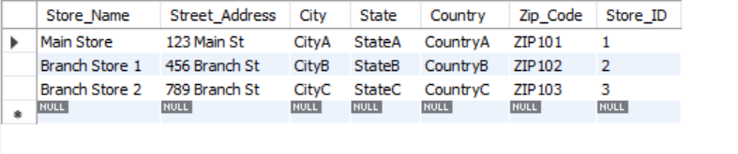

**Transacts Table:**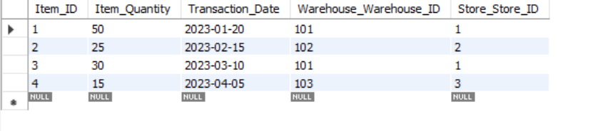

**Shipment Facilitator:**



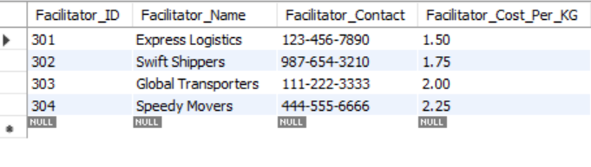

**Shipment Table:**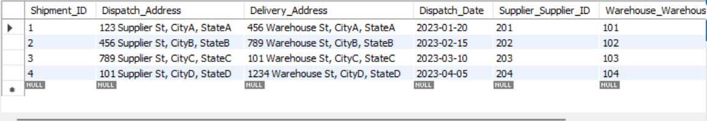

**Supplier Table:**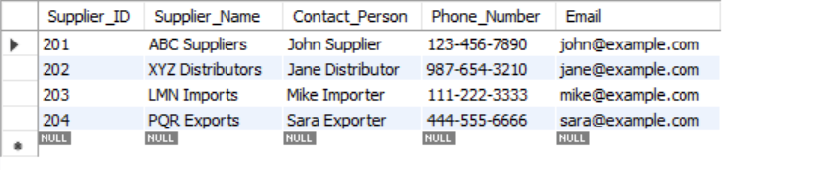

**Item Table:**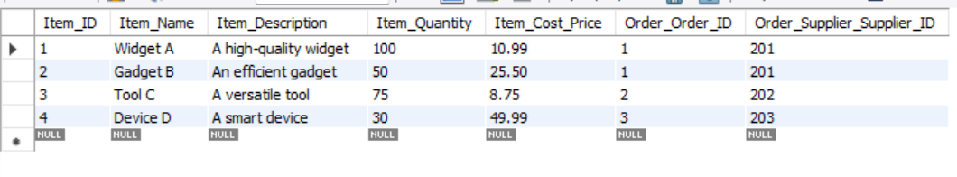

**Order Table:**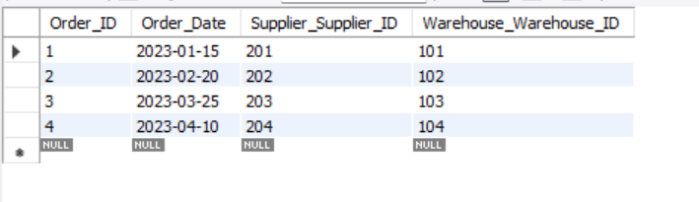

**Invoice Table:**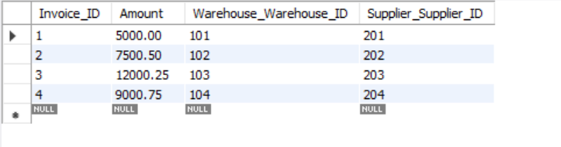

**Employee Table**